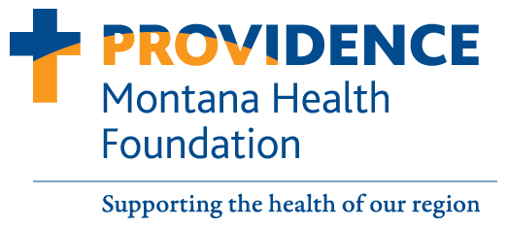
P.O. Box 4587
Missoula, Montana 59806
406-329-5640

Yes! I would like to give to the
Providence Montana Health Foundation

Enclosed is my tax-deductable gift of:

□ $500.00 □ $250.00 □ $100.00 □ $50.00 □ Other: __________________

Please allocate this donation to:

□ St. Patrick Hospital’s greatest need □ The International Heart Institute/Cardiology
□ Cancer/Team Up Montana □ Ed/Trauma
□ Brain Injury/ Neurosciences □ St. Patrick House
□ Other: _____________________________

Payment options:

□ Check enclosed (Please make checks payable to Providence Montana Health Foundation)
□ Charge my credit card □ Visa □ MC □ American Express □ Discover
Card Number:__________________________________________________________________
Exp. Date:________ CVV2 Code:_____ Name on card: ___________________________
Signature:_____________________________________________________________________
Email: ______________________________________________________________________________

I would like to make this gift in honor/memory of: __________________________________________
Please send acknowledgement to:
Name__________________________________________________________________________________
Address________________________________________________________________________________

To learn about other programs, services and ways to give, please contact the Providence Montana Health Foundation
at 406-329-5640 or visit Supportpmhf.org

.

