2021 Age Friendly Innovation Challenge

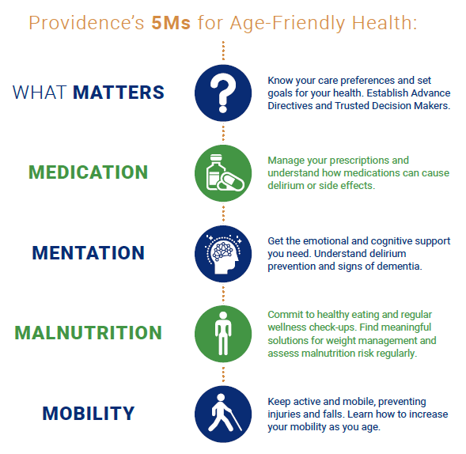
Overview
The Age Friendly Innovation Challenge encourages our caregivers and clinicians to bring their ideas to life through one-time grant awards that align with building an Age Friendly Health System. The Providence Age Friendly Health System promotes the 5Ms for age-friendly health: What Matters, Medication, Mentation, Malnutrition and Mobility.

Our goal is simple: to make all care for older adults age-friendly care – guided by essential evidence-based practices (5Ms), causing no harm and aligning with what matters most to the older adult and their family.

Purpose of the Innovation Challenge
Our caregivers and clinicians are the experts when it comes to knowing what it takes to serve our patients and communities best, and this innovation challenge is intended to spark creativity, generate idea diversity, grow a culture of innovative thinkers and recognize and support the resourcefulness of those passionate about delivering age friendly care.

Innovation Challenge in a Nutshell:
- Challenge will consist of two phases: proposals and a “pitch fest” where finalists present their idea to a panel who determines the final awards.
- Proposals will be accepted through June 30, 2021 and finalists for the pitch fest will be announced in mid-July. The pitch fest will be held in early to mid-August.
- Project grant awards of up to $100,000 are available, though smaller grant requests are welcome.
- Projects should be “shovel ready” so that work can begin immediately after awards are granted in August.

Application Process:
- A simple application process is involved, and sessions will be held to help participants with less experience produce well-developed and articulated projects.
- Projects should reflect and strengthen the delivery of age-friendly 5M care to older adults. Projects focused on integrating the 5Ms are strongly encouraged, but applicants are welcome to submit a proposal focusing in on a particular aspect of age friendly care.
- Special consideration will be given to projects that address the intersection of health equity and age-friendly care.
- A final summary reports on project outcomes will be requested to help disseminate learning throughout the system.
- Winning projects will be featured at next year’s Age Friendly Health Symposium and other potential forums.

Eligibility
Caregivers and clinicians in the Providence brand family are eligible to apply. Applications created jointly with external partners are welcome.

Key Dates
- May 5 – Open call for proposals
- Late May/Early June (to be scheduled) – Coaching sessions
- June 30 – Proposals due
- July 16 – Finalists notified (note – all applications receive feedback)
- Early/Mid-August (to be scheduled) – Pitch fest and awards
- 2022 – Age Friendly Innovation Showcase at Age Friendly Health Symposium

Questions and Inquiries
Questions and inquiries are welcome and can be sent to the Office of Clinical Care.
Age Friendly Innovation Challenge
Proposal Application
Due: June 30, 2021

Title of the Project
Sponsoring Leader & Department
Sponsoring Department Cost Center
Project Leader or Contact Name Info
Name & Title
Email Address
Best Contact Phone #
Persons in Group/Team Involved in Project (Please list names with titles)

Indicate your project’s alignment with the Providence 5M Age Friendly Health System framework | ___ Care integration with all 5 Ms  ___ What Matters  ___ Medication  ___ Mentation  ___ Malnutrition  ___ Mobility

Important requirements:
- Application must be no more than 3 one-sided, single-spaced pages (Beginning with Executive Summary and Ending with Sustainment plan) using 10 pt. Arial font.
- This cover page, along with signature page (Director level or above endorsement) and budget form are required. These pieces do not count toward the three page limit.
- Completed application must be returned by June 30, 2021 via the grant portal (link to portal to be added to Sharepoint site by the first week of June).
Required Application Components
Note: The actual application will be loaded into a grants portal and information for linking to the portal will be available on the Sharepoint site by early June.
Executive Summary Please summarize request in a succinct, straightforward manner, briefly outlining your project or program’s purpose and goals. Limit: 150 words
Description of Need. Brief description of why your project or program is necessary.
Description of Goals. Identify up to three goals that express the overarching impact of your project
Description of Intended Outcome. Identify one or more outcomes you intend to reach during the grant cycle. Outcomes should be specific, clearly-defined and quantitative
Individuals Served and Population Affected Who (patients, nurses, physicians, families, community members, etc.) will the project or program impact and how many do you project will be served?
Health Equity. Describe how/if the project addresses health equity, and how the opportunity can be approached to minimize disparities based on racial, ethnic, language, and/or socio-economic differences.
Project Description. Include relevant details about project implementation, logistics, etc. A well-developed project description will help secure the confidence of judges that the project or program has been well considered and is primed for funding.
Project Challenges. Describe the top challenges you anticipate encountering in this project or program and how you anticipate they will be managed.
Sustainment Plan. If this project or program continues outside the grant period, how will it be sustained financially?
Budget. Utilize budget form to outline requested funds by category, along with background on how costs were calculated and/or determined.

ENDORSEMENT: Proposals must be endorsed by someone on the management team at a Director level or above.

_____________________________________________
Leader Name

___________________________________________________________________
Leader Signature Date

Budget Form
Note: The actual application will be loaded into a grants portal and information for linking to the portal will be available on the Sharepoint site by mid-May.

- Your budget must be completed and itemized. Please do not round up, and check to make sure numbers add up correctly.
- Line items below are examples only; listed items can be replaced and/or new items may be added. Please ensure the total reflects the grant award amount requested in the application.
- Comments on how costs were calculated/determined are expected and will strengthen your proposal.

Category/Item | Total Requested | How Cost Was Calculated/Determined
Temp/Consultant
Equipment
Meeting Supplies
Training Materials
Office Supplies
Travel
Evaluation
Etc.
Total Request

Are offsetting revenues and/or cost reductions anticipated? Please describe if not already described within body of the application.

Tips:
- Temp/consultant – show rates; for consultants show rate inclusive of expenses as needed
- Equipment – include all costs, e.g., purchase price, tax, shipping, installation, maintenance
- Travel – include all aspects, mileage (53.5 cents per mile), airfare, hotel, transportation, meals.

