OTHER OSEPH
WORD SEARCH
The list below consists of 32 words related to Mother Joseph's life and character. Can you find and circle each of the words in the diagram? Words are formed forward, backwards, up, down, and diagonally. Some letters will be used more than once, so some words overlap. You will not use all the letters in the diagram.
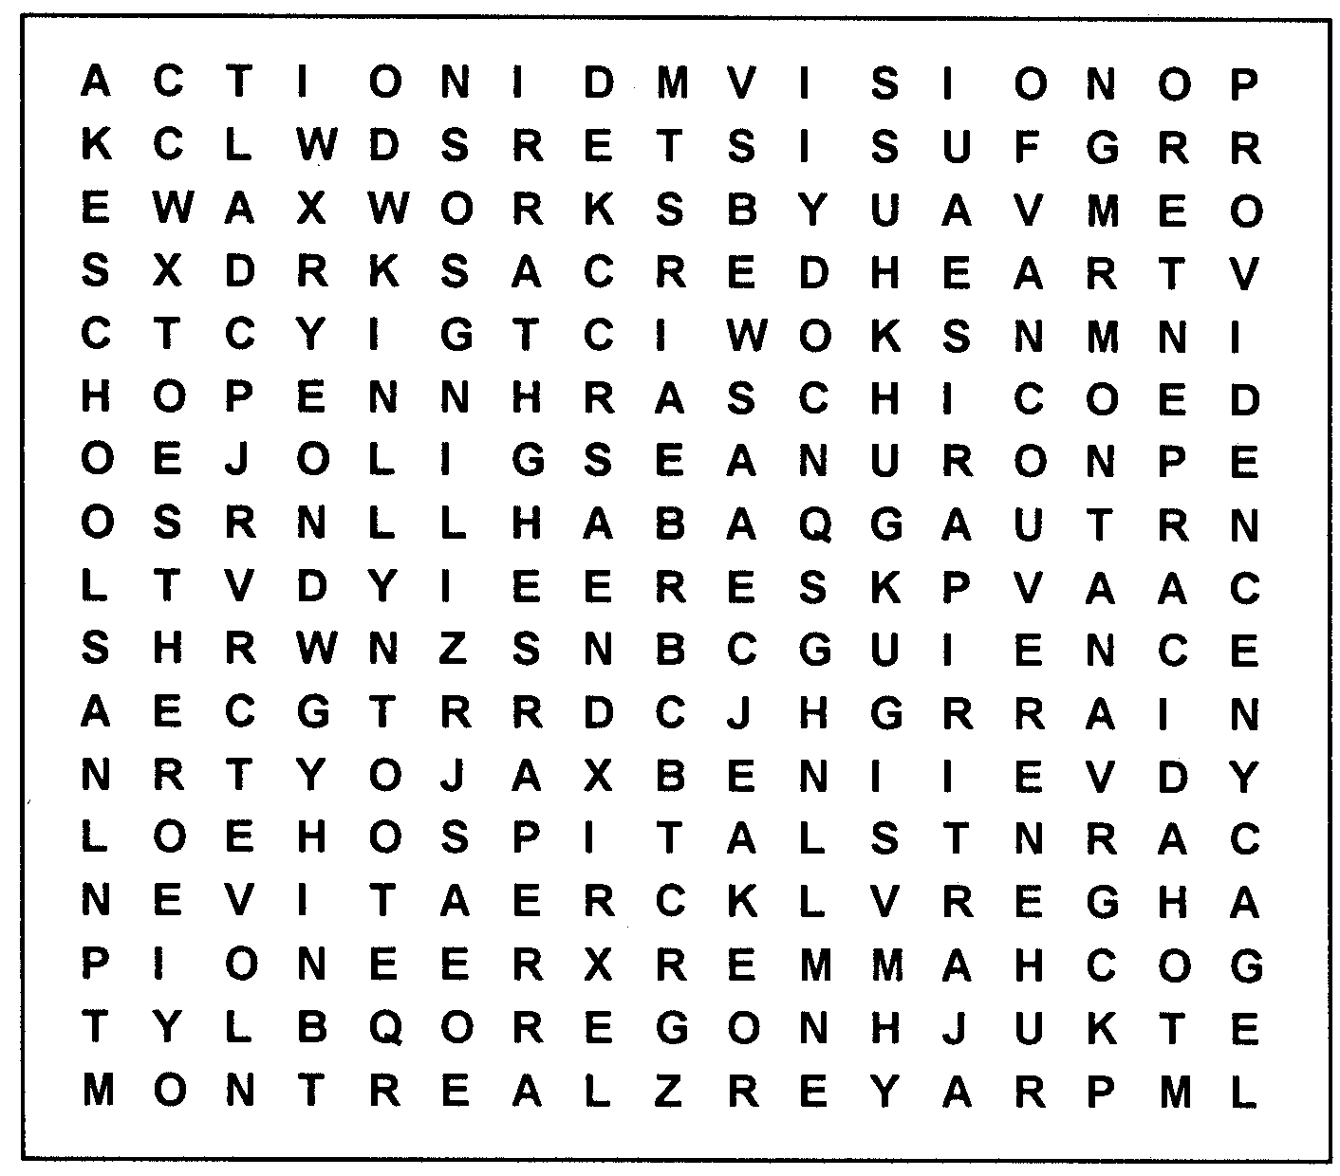

ACTION  ARCHITECT  BEGGING  CARING  CARPENTER  CHILDREN  CREATIVE  ESTHER* | EXCELLENCE HAMMER  HOPE  HORSEBACK HOSPITALS  IDAHO  LEGACY  LOVE | MONTANA  MONTREAL  OREGON  PARISEAU*  PIONEER  PRAYER PROVIDENCE SACRED HEART | SCHOOLS  SISTERS  STRONG  TREASUER  VANCOUVER  VISION  WASHINGTON  WAXWORKS
*Mother Joseph's given name

Mother Joseph Centennial Year ▪ 2002
archives@providence.org
MOTHER JOSEPH WORD SEARCH SOLUTION
