


Step 1: Claiming Your Account
*Previous students/employees skip to “Unlock your account or reset your password”. Multi-factor Authentication must be set up previously to complete this step.
For security reasons, you will be required to claim your account to obtain your login ID.
- Navigate to https://access.providence.org
Step 1a: Click on “Claim Your Account”
Step 1b: Complete all fields (First Name, Last Name, Date of Birth, Last 4 of Social Security #)
Step 1c: Click the blue “Verify” button on the bottom right of the screen.
Step 1d: Read and agree to the Providence Acceptable Use Agreement (Click the blue “I Agree” button on the bottom right).
Possible Error Message:
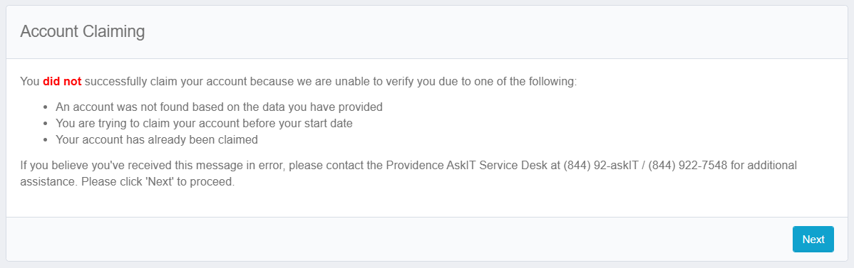
If you receive this message, please try to login 1 additional time by first clicking the next button, then the home button. If the issue persists, contact Providence IT Support 844-922-7548.
**If you are a current/past employee or have previously had a clinical rotation at ANY Providence facility, you will get the error above when claiming. If you remember your ID, please skip to step 5. If you do not remember your ID (and or password), contact Providence IT Support as mentioned above.
Step 2: Setting Security Questions
Security Questions will be used to verify identity for password assistance if a call to the Service Desk is required. You will need to create your Security Questions and Answers.
Step 3: Creating Your Password
Providence Password Requirements:
- Minimum 10 characters
- The password must contain 3 out of 4 of the following:
  - Lower case letters (a - z)
  - Upper case letters (A - Z)
  - Digits (0 - 9)
  - Special characters (~!#$%^&*_-+=`|\(){}[]:;"'<>,.?/@)
- You cannot reuse previous passwords
- Proper names cannot be used
***ANY word that could be recognized by the computer such as dictionary words cannot be used. The system will allow you to set your password, but it will NOT work when you go to sign in.
Click the blue “Submit” button. Write down your password somewhere safe so you have it when you come to clinical.
Step 4: Receive Providence ID number
You will receive your Providence network logon ID. This login ID will get you into the Swedish computers. There will be other ID’s listed, but you do not need them. Please write the network logon ID down somewhere safe.
Example: rachel.wabeke
Example: n5364874
Example: p432635
Step 5: Set Up Multi-Factor Authentication (MFA)
After receiving your Providence network login, click continue, returning you to the home screen where you first clicked on claim account.
Step 5a: Click on “Configure Multi-Factor Authentication”. You may use the video walkthrough or PDF walkthrough to assist in setting this up. If you are taken to a screen where it wants to send you a code to your phone number, you might have set up the MFA already and do not need to proceed further in this step.

